**Module – Beyond Basic Machine Learning**

Natural Language Processing models are used to deal with textual data, Deep Learning models are used to deal with much more complex data such as images and videos.

**Introduction to unstructured data analysis**

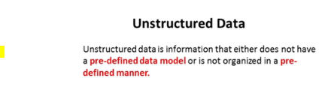

Types of unstructured data

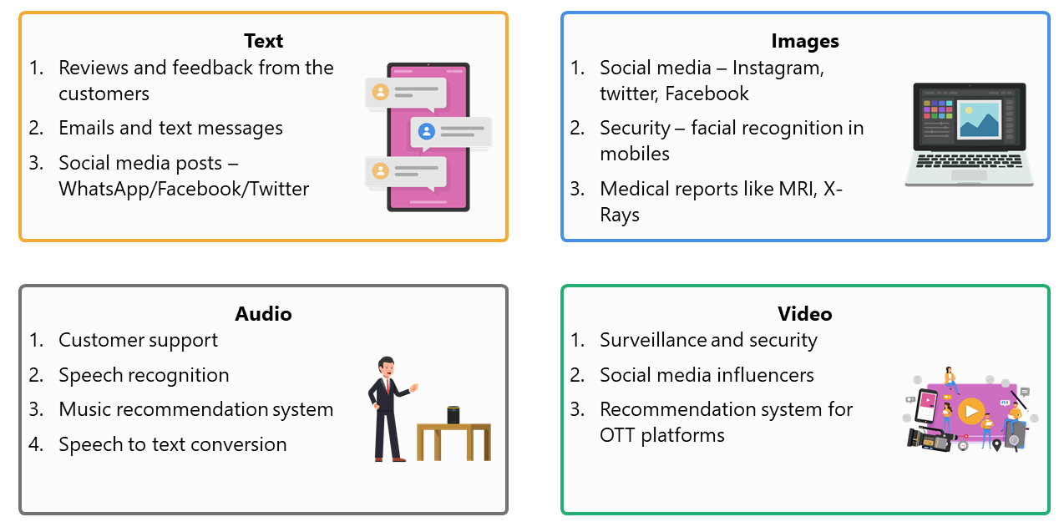

Applications of unstructured data

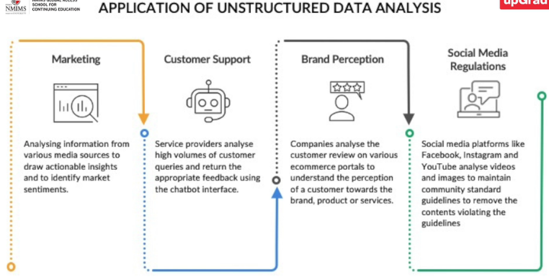

**Natural Language Processing: Intuition**

Natural language processing is also referred to as text analytics.

To analyse natural language, a specific subfield of machine learning is used, which is known as Natural Language Processing (NLP)

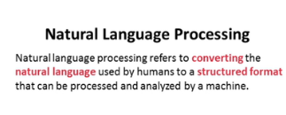

Two components of NLP:

1. Natural Language Understanding – can the model understand what is being communicated.
2. Natural Language Generation – can the model respond in a human understandable language to a communication.

Major fields of application of NLP

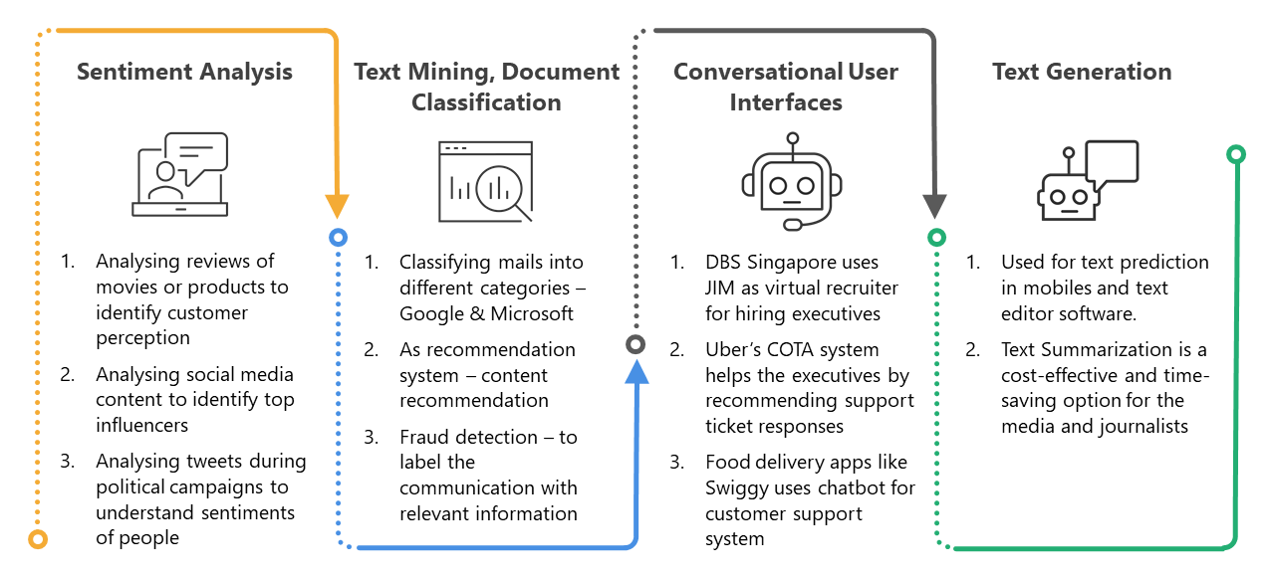

NLP Algorithm - How does the model identify the text and give you the output?

A machine learning model follows a set of rules to convert natural language into a format that a machine can readily understand. This set of rules forms the algorithm of NLP.

NLP breaks any given text and converts it into a machine-readable format using a five-stage process, which is depicted in the diagram given below:

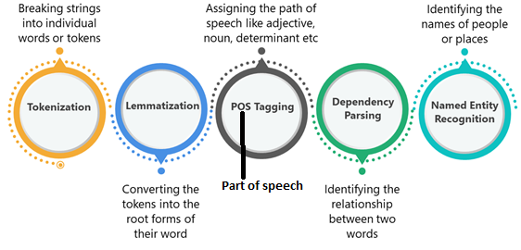

Tokenization

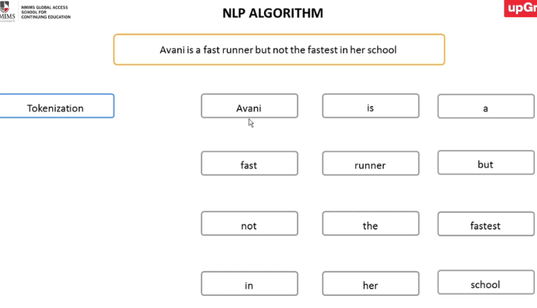

Lemmatization

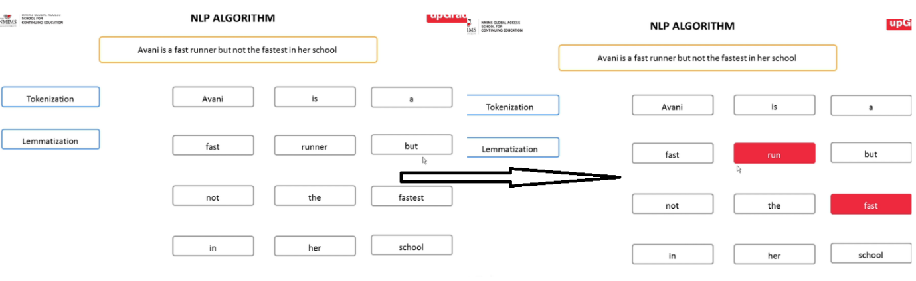

Part of Speech Tagging

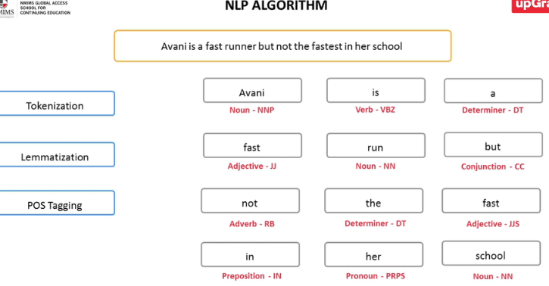

Dependency parsing

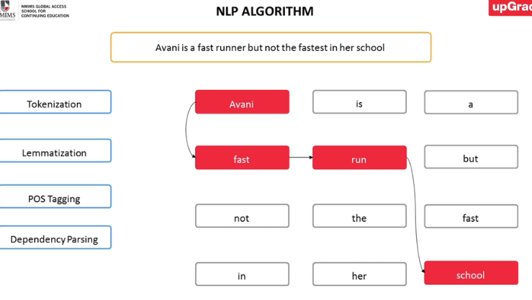

Named entity recognition

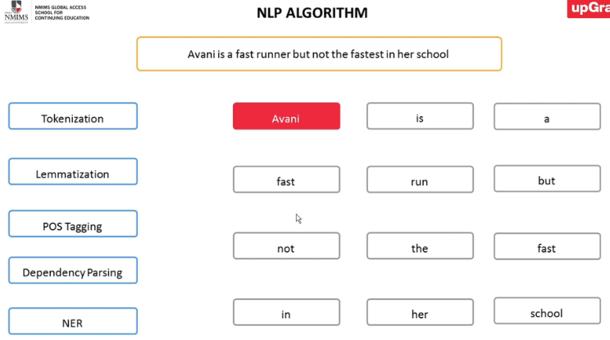

**Deep Learning**

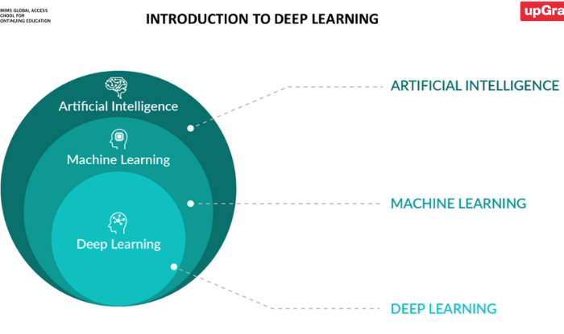

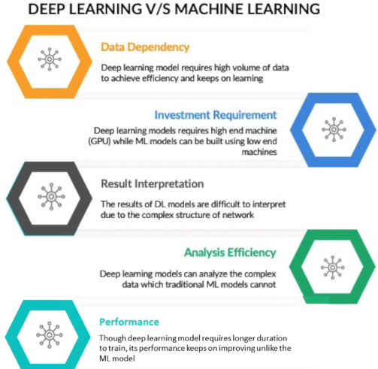

Areas of application of deep learning

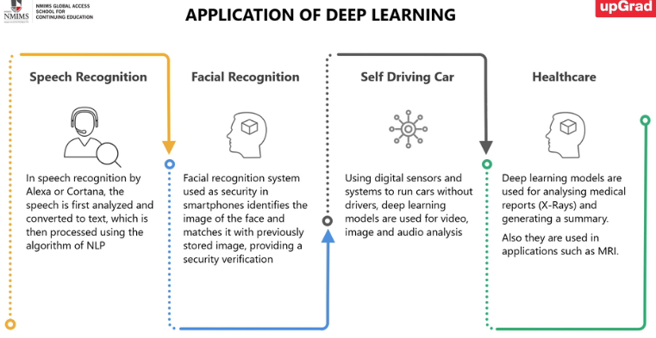

**Neural Networks**

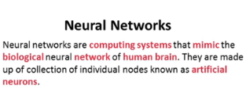

Note that everything in neural networks has to be number. You can’t use categorical variables.

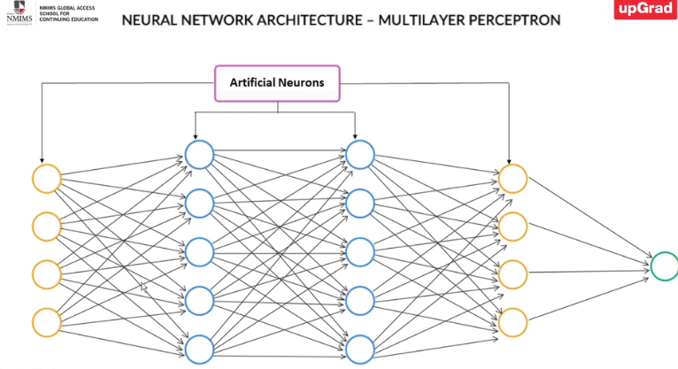

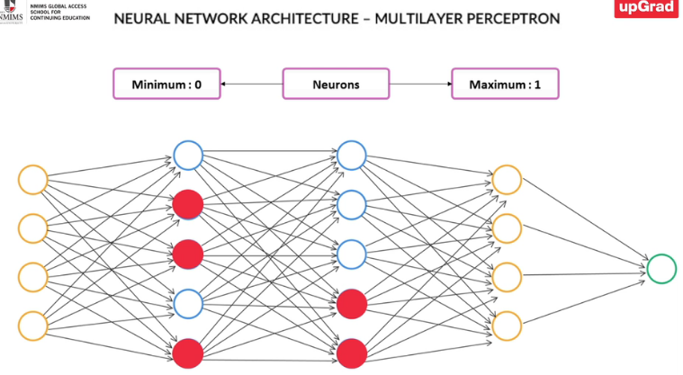

The core idea of deep learning is to mimic the human brain; the structure of the brain is recreated using artificial neurons. These neurons form the basic structure known as the perceptron.

Perceptrons take some signals as inputs and perform a set of simple calculations to arrive at a decision. These perceptrons form the basic neural network structure known as multilayer perceptron.

Multilayer Perceptron has three types of layers, which are as follows:

* **Input layer**: This is the first layer; it captures the input.
* **Hidden layer**: Also known as the processing layer, this layer is responsible for identifying the different patterns of the input.
* **Output layer**: This is the last layer; it compiles identified structures as well and generates an output that a machine can understand.

The **algorithm of a neural network that consists of three components**, which are as follows:

1. **Weights**: Each neuron has a different weightage, and hence, its contribution to the output varies.
2. **Biases**: Biases are introduced in networks to shift the output by the desired value
3. **Activation function**: Since a neuron can only take a value between 0 and 1, the output received by the weighted average of all the input neurons needs to be converted to this range. For this transformation, a function (generally sigmoid) is used

The value of a particular neuron, taking input from previous layers, can be given by the following equation:



Here,

* W represents the weights,
* X is the value of a particular input neuron, and
* B is the bias.

A neural network learns by trying to minimise the difference between the input and the output. The two-dimensional approach, in this case, is known as the cost function.

Optimisation is trying to look at weights (Wi)such that Cost Function is minimum (Output -Input )2.

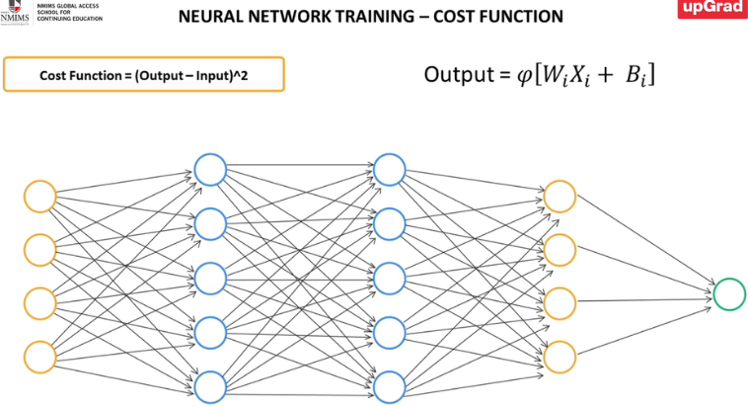

**Types of Neural Networks**

1. Convolutional Neural Network: This is used mainly for image and video analysis. It has two layers:
   1. Convolutional layer: It is the layer that has different metrics, each metric represent a different label or feature.
   2. Pooling layer: It combines or pools the different convolutional layer to reduce the dimension of data

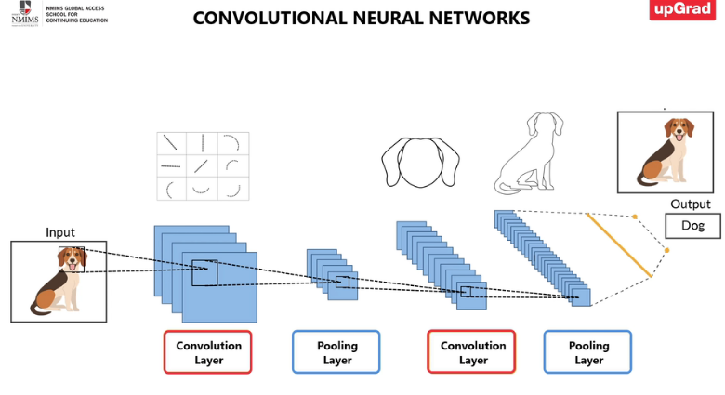

1. Recurrent Neural Network: This is used mainly for audio analysis.

Their network architecture is depicted in the image given below

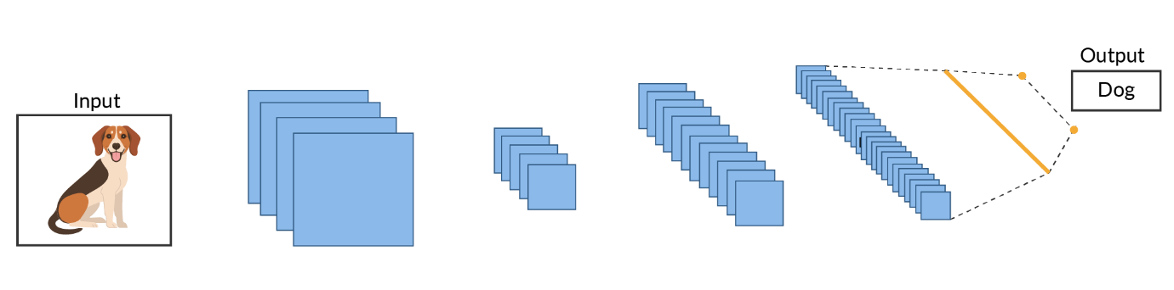

Recurrent Neural Network

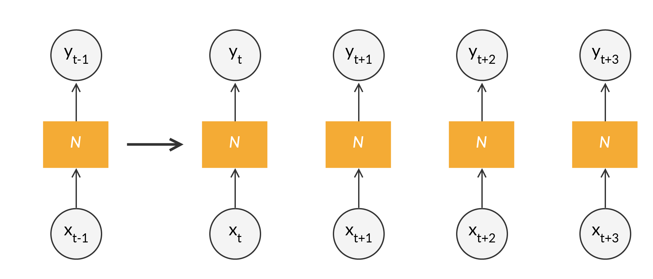

Applications of Recurrent Neural Network

